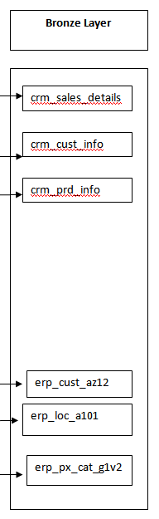

**DATA FLOW DIAGRAM**

Dim_products

Dim_customers

Fact_sales

**Gold Layer**

**Silver Layer**

CRM Folder

ERP Folder

erp_cust_az12

erp_loc_a101

erp_px_cat_g1v2

crm_prd_info

crm_cust_info

crm_sales_details

**Bronze Layer**

**Sources**